Marwadi Education Foundation’s Group of Institutions

Information Technology (IT)

Engineering Department



Subject: Software Engineering (**2160701)**

Project Report



**CERTIFICATE**

This is to certify that **May Mon Myint** (150570116037) of B.E. Semester **VI (Information Technology Engineering)** has completed his **Software Engineering** work for the project entitled “**Guida System**” satisfactorily in fulfillment for requirement of **Software Engineering** course, Gujarat Technical University, Ahmedabad, in the academic year **2017-2018.**

**Sign of Faculty Guide**

Prof. Navjyotsinh Jadeja



**CERTIFICATE**

This is to certify that **Trupti Yadav** (150970116035) of B.E. Semester **VI (Information Technology Engineering)** has completed his **Software Engineering** work for the project entitled “**Guida System**” satisfactorily in fulfillment for requirement of **Software Engineering** course, Gujarat Technical University, Ahmedabad, in the academic year **2017-2018.**

**Sign of Faculty Guide**

Prof. Navjyotsinh Jadeja



**CERTIFICATE**

This is to certify that **Shraddha Kanara** (150574116002) of B.E. Semester **VI (Information Technology Engineering)** has completed his **Software Engineering** work for the project entitled “**Guida System**” satisfactorily in fulfillment for requirement of **Software Engineering** course, Gujarat Technical University, Ahmedabad, in the academic year **2017-2018.**

**Sign of Faculty Guide**

Prof. Navjyotsinh Jadeja



**CERTIFICATE**

This is to certify that **Kinjal Gaushvami** (150574116001) of B.E. Semester **VI (Information Technology Engineering)** has completed his **Software Engineering** work for the project entitled “**Guida System**” satisfactorily in fulfillment for requirement of **Software Engineering** course, Gujarat Technical University, Ahmedabad, in the academic year **2017-2018.**

**Sign of Faculty Guide**

Prof. Navjyotsinh Jadeja

**Acknowledgements**

* I express my cavernous sense of obligation and gratitude to my Guide Prof. NAVJYOTSINH JADEJA for her genuine guidance and constant Encouragement throughout this project work. I am highly obliged as my honorable guide for providing me such an opportunity to carry out research work under her continuous guidance.
* I extend my sincere thanks to Prof. Sunil Soni Head Of Department of Information Technology have devoted his valuable time and shared his expertise knowledge.
* I also wish to express my heartfelt appreciation to my friends, colleagues and many who have rendered their support for the successful works towards the completion of the research work, both explicitly and implicitly.
* We Choose This Topic Because We Realize Our Responsibility Towards the Nation. So We discover that many of people face problem in Communicating with foreigners.
* In This System People who are coming from outside can go through this and find where they wants to go etc. And they can also find the right place where they can stay.

**Abstract**

* In our project, we are doing **‘Guida System’**. In this project we are trying to construct a system in which there is high accuracy, save time and easily people can find the space of their comfort zone.
* The people need not go to the every place and check which one is better and which is not. They can use the service of the system and they can give their needs or necessity and we are provide the best outputs.
* Our System is basically connecting people of any city and this system will help the both type people who are out sider and the resident.

**Objective And Functionality**

* + Profile
  + Mandatory form
  + Search Box
  + Feedback
  + Monitoring System
  + Google API
  + Google Maps
  + Contacts
  + Chat Box (Group)

**Product Scope**

* No Need to sign in
* Must use the browser
* Basic knowledge about internet
* Better to have smart phone



* To make android application for comfort
* Bulk message service
* Launch in market
* Solve the limitation
* Add up more places
* Add up Fast Communication with users

Tables:

RMMM Table:

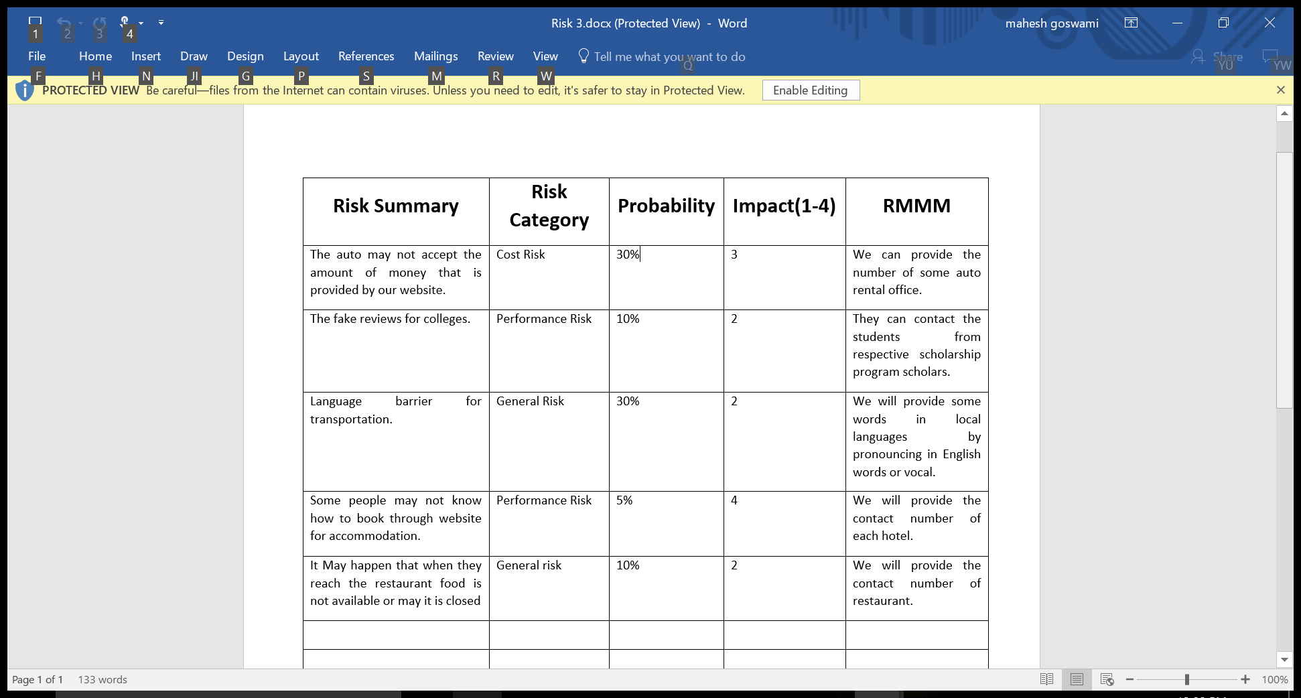

Chart:

Gantt-Chart:

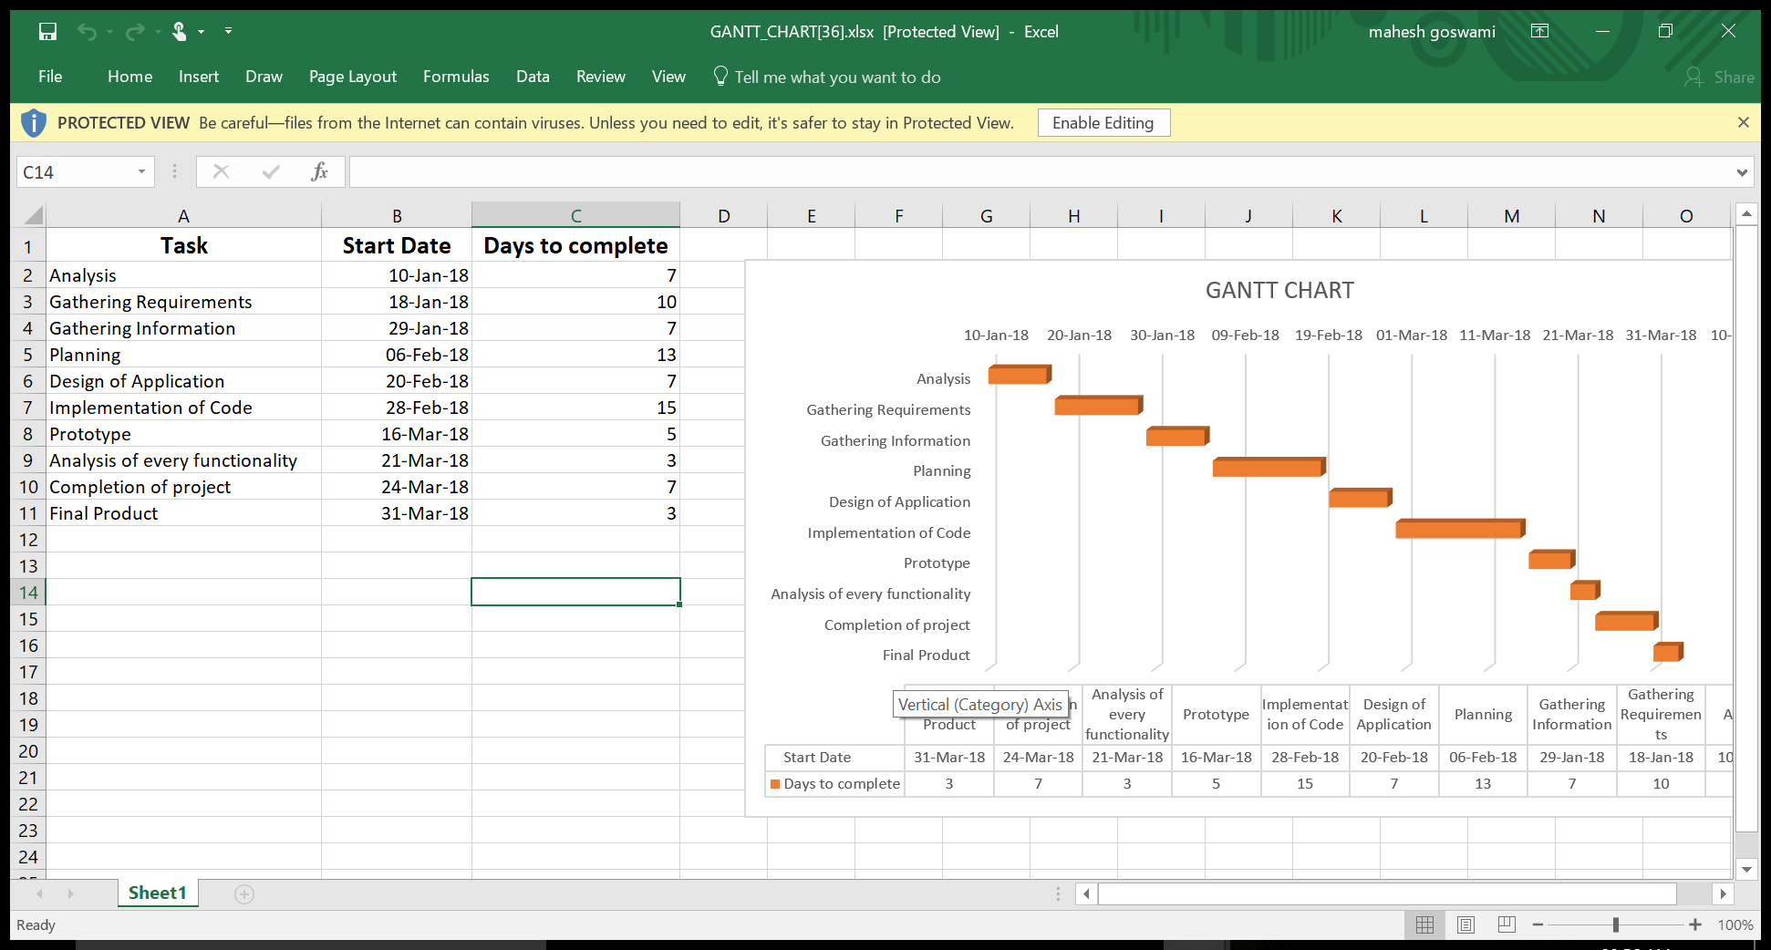

RTM Chart:

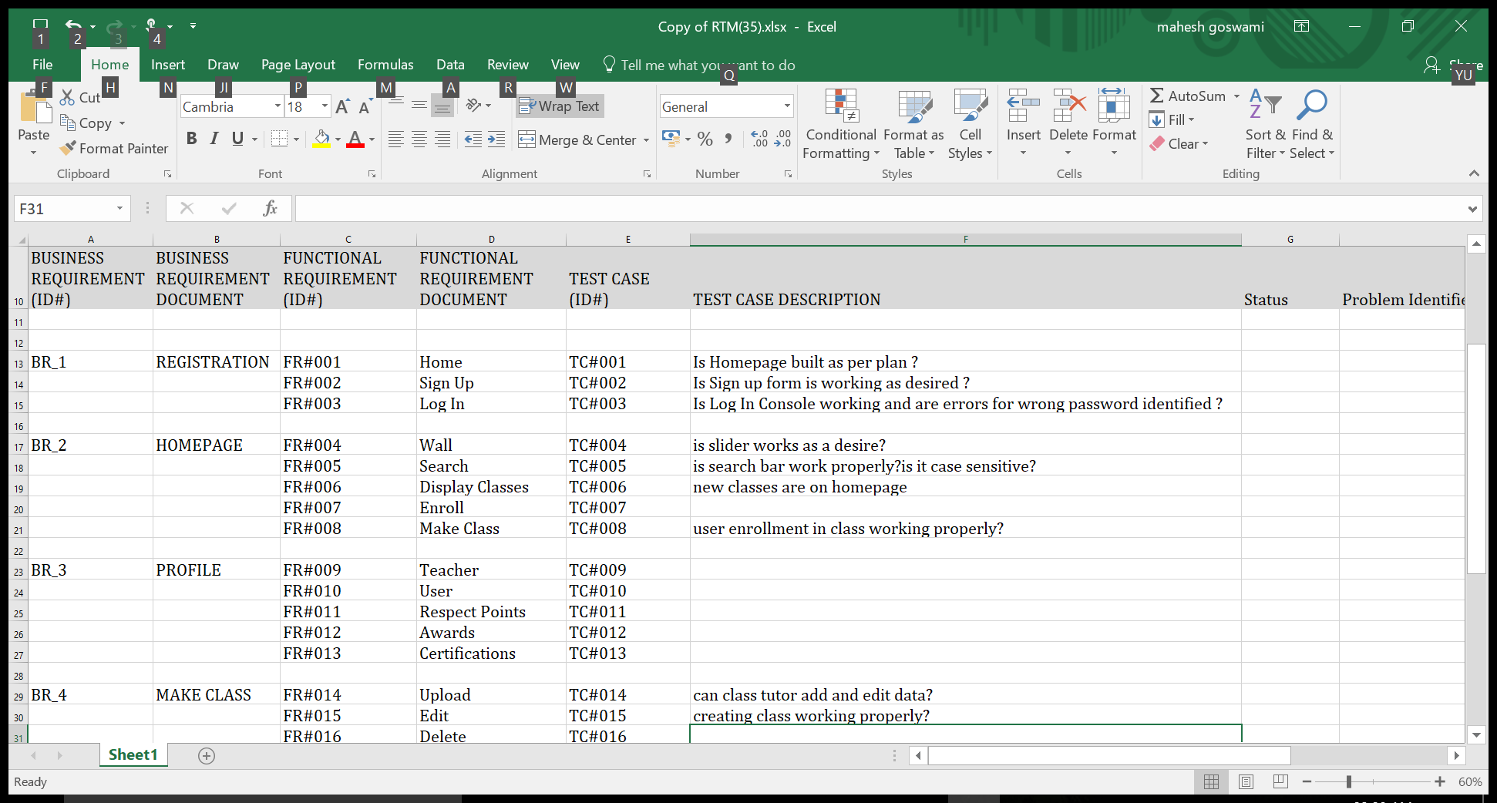

REFERENCES:

* <https://indianfrro.gov.in>
* [www.airbnb.co.in](http://www.airbnb.co.in)
* [www.cfo.gov.ph](http://www.cfo.gov.ph)
* <https://maps.google.com>
* [www.researchgate.ne](http://www.researchgate.ne)
* [www.localyse.eu](http://www.localyse.eu)
* <https://www.quora.com>
* [www.youtube.com](http://www.youtube.com)

**Table of Content:**

1 .Candidate`s Declaration……………………………………………1

2 .Acknowledgement…………………………………………………. 2

3. Abstract…………………………………………………………….. 3

4. Notation, Naming Convention and Abbreviation………………….. 4

5. List of Table………………………………………………………... 5

6. List of Chart

1. Gantt-Chart…………………………………………………. 6

2. RTM-Chart…………………………………………………. 7

3. Traceability matrics

7. References………………………………………………………….. 8